**How to update from version 2.4 to Version 2.5**

Please follow the below steps

Open vendor App in Android studio.

1. Open the driver folder

Replace the **lib** folder in your 2.4 source code folder.

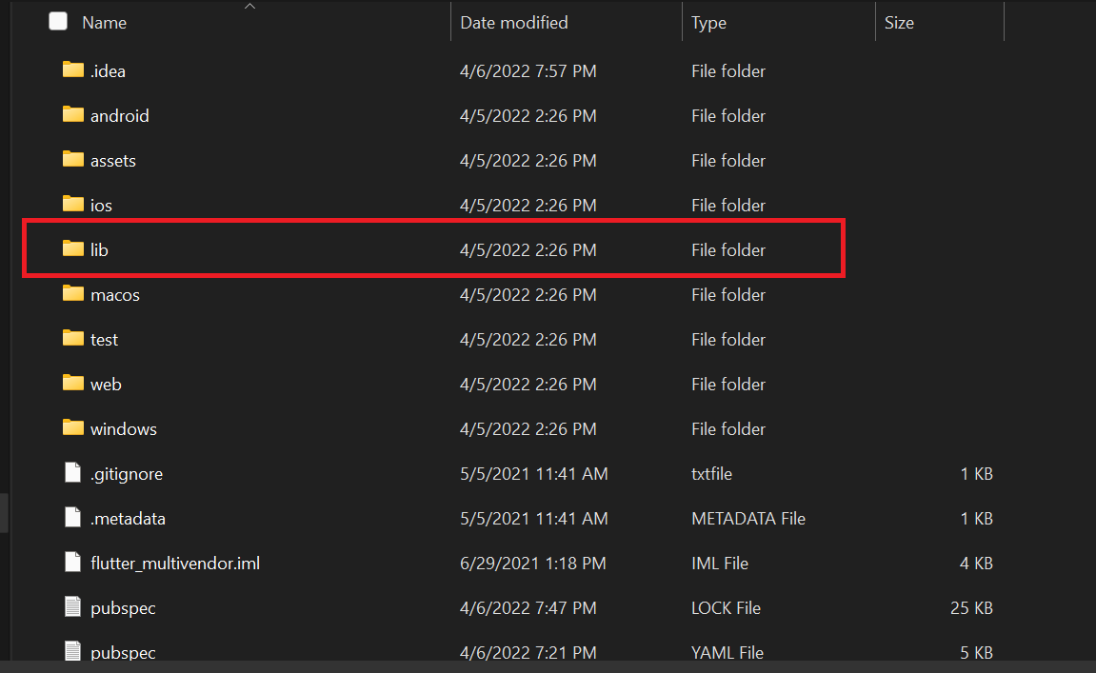

Replace the **pubspec.yaml** file in your 2.3 source code folder.

